Soda.io Second Take

Today I continued to set up my soda sql command line interface.

Many different tryouts:

1. I thought that I didn’t have the postgres database. I checked them and I do have them. By calling .\psql I was able to run SQL command lines on windows powershell. 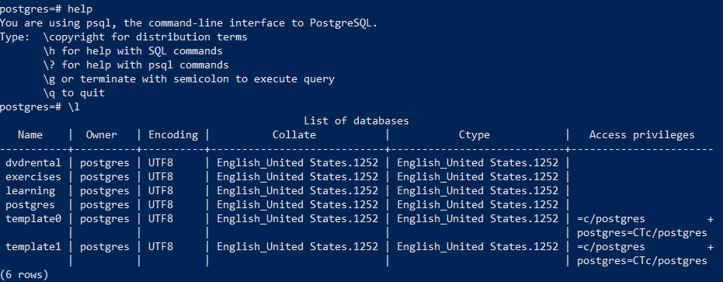
2. I re-installed soda-sql-postgresql. There were two errors that kept the installation being successful. First one is the installation of psycopg2-binary. I tried manually installed the library by using pip and re-installed soda sql but it still had the same error. Then I found the second error was about the version of the Visual Studio and the C++ compilers and libraries, etc. So I installed the latest visual studio build tools and install the C++ kit. After all, the soda sql was installed successfully with a couple warnings but no errors. However, the programmatic access still didn’t go through.
3. After making sure that all dependencies or other needed packages were installed properly, I started to look at the traceback of the errors. 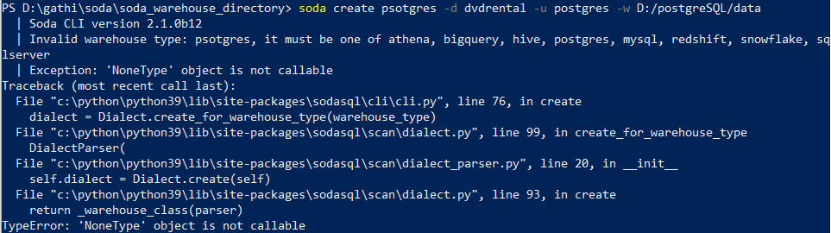 But I don’t know how to debug them.

After trying multiple solutions but not making it run, I put soda aside and started to look into Great Expectation. I do not have much details for now. I would keep looking at its codes and documentations after dinner. I would include this part into my tomorrow’s blog.